Chapter 17, Solution 53.

ω_{o} = 2π/T = 2π

c_{n} = 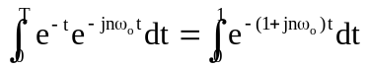

= 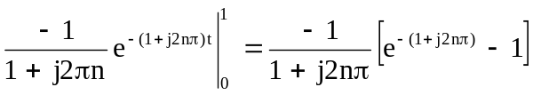

= [1/(j2nπ)][1 – e^{–1}(cos(2πn) – jsin(2nπ))]

= (1 – e^{–1})/(1 + j2nπ) = 0.6321/(1 + j2nπ

f(t) = 